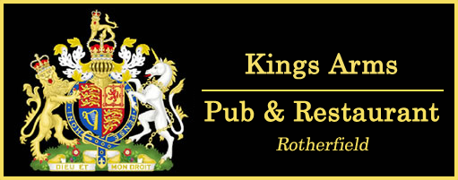

Menu
Ciabatta Sandwiches:

[Lunch only Mon-Thurs 12-3pm & Fri-Sat 12-6pm]

Roast beef & horseradish £6.50
Chicken & bacon club £6
Tuna mayo crunch, spring onion & celery £6
Prawn & dill mayonnaise £6.50
Brie & grape (v) £6
Vegan Bavarian sausage, sauerkraut & mustard relish (Vg) £8

Starters
Asparagus with streaky bacon, bacon panko crumb, poached egg & parmesan £8
Chicken Caesar salad, garlic croutons, anchovies & parmesan shavings £7 / £12 (GFO)
Crispy whitebait, tartare sauce & toasted ciabatta bread £6.50
Salt & pepper king prawns, Chinese style salad £8 (GF)
Sun-blushed tomato & goats cheese crostini, toasted pine nut puree & basil pesto (v) £6
Caprese salad, mozzarella, vine ripened tomato & caramelised red onions (v) £6 (GF)

Mains

Venison burger, griddled pear on a sesame bun, fries & fennel coleslaw £16 (GFO)
Asian style chicken salad, sweet chilli & lime £14
Chicken Souvlaki, Greek salad, tzatziki & pitta £14
Beef burger, streaky bacon, Monterey Jack cheese, tomato relish in a sesame
bun & fries, fennel coleslaw £16 (GFO)
Pan seared lambs liver, sauteed potatoes, buttered spinach, streaky bacon,
seasonal vegetables & onion gravy £12 (GF)
Grilled whole sardines Provençale, green salad & olive oil baked garlic ciabatta £12
Grilled seabass fillet, Mediterranean vegetables, streamed rice & garlic king prawns £16
Roasted Mediterranean vegetable lasagne, garlic ciabatta & salad (v) £12
Indian spiced halloumi burger, mango chutney, red onion, sesame bun &
sweet potato wedges (v) £14 (GFO)
Wild mushroom & leek duxelles Wellington, Costal cheddar & chive crushed new potatoes,
seasonal vegetables & white port gravy (v) £14
Pizza £13 (please ask for our pizza menu)

Sides

Chips £3.50 (GF); Cheesy chips 4.50 (GF); Cheesy chips with bacon £5 (GF); Garlic Ciabatta £3.50

Corn on the cob £3.50 (GF); Greek salad £3.50 (GF); Mixed vegetables £ 3.50 (GF)

